Assignment 1: build your business web site.
- First and above all you need to define your vision, mission and objectives.
- You need to answer the following questions :
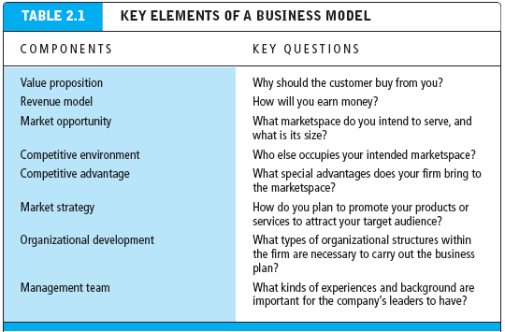
- Start your logical design by sketching on white paper how your web site will look like and how the mission and the objectives are consistent to this design.
- Transfer this logical design to become a physical design.
GOOOOOOD Luck

